

SRI LANKA INSTITUTE OF INFORMATION TECHNOLOGY

[**Enterprise Standards and Best Practices for IT Infrastructure**](http://courseweb.sliit.lk/course/view.php?id=137)

**4th Year 2nd Semester 2014**

Name: H.K.V.P Silva

SLIIT ID: IT 13 127992

Group Number:

Practical Session: WE Monday

Practical Number: Lab 1 and 2

Date of Submission:

Date of Evaluation : _____________________

Evaluators Signature : ___________________

**How to create a Windows instance using AWS?**

Open up your browser and go the AWS page then using your username passwords login to the AWS server.

1. Select “EC2” component under “COMPUTE” category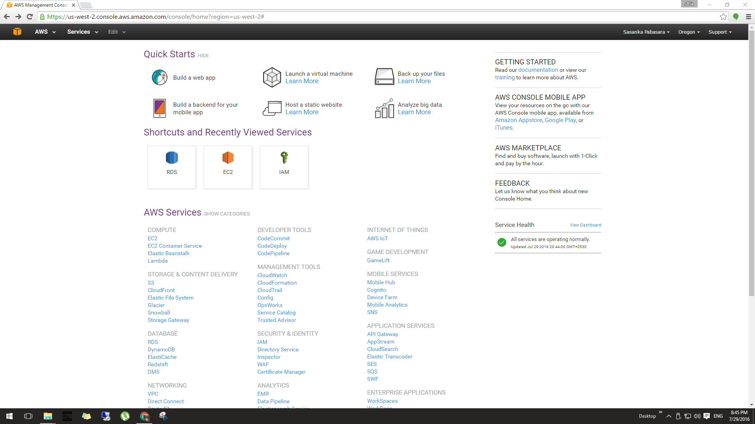
2. Click “Launch Instance” to launch an operating system instance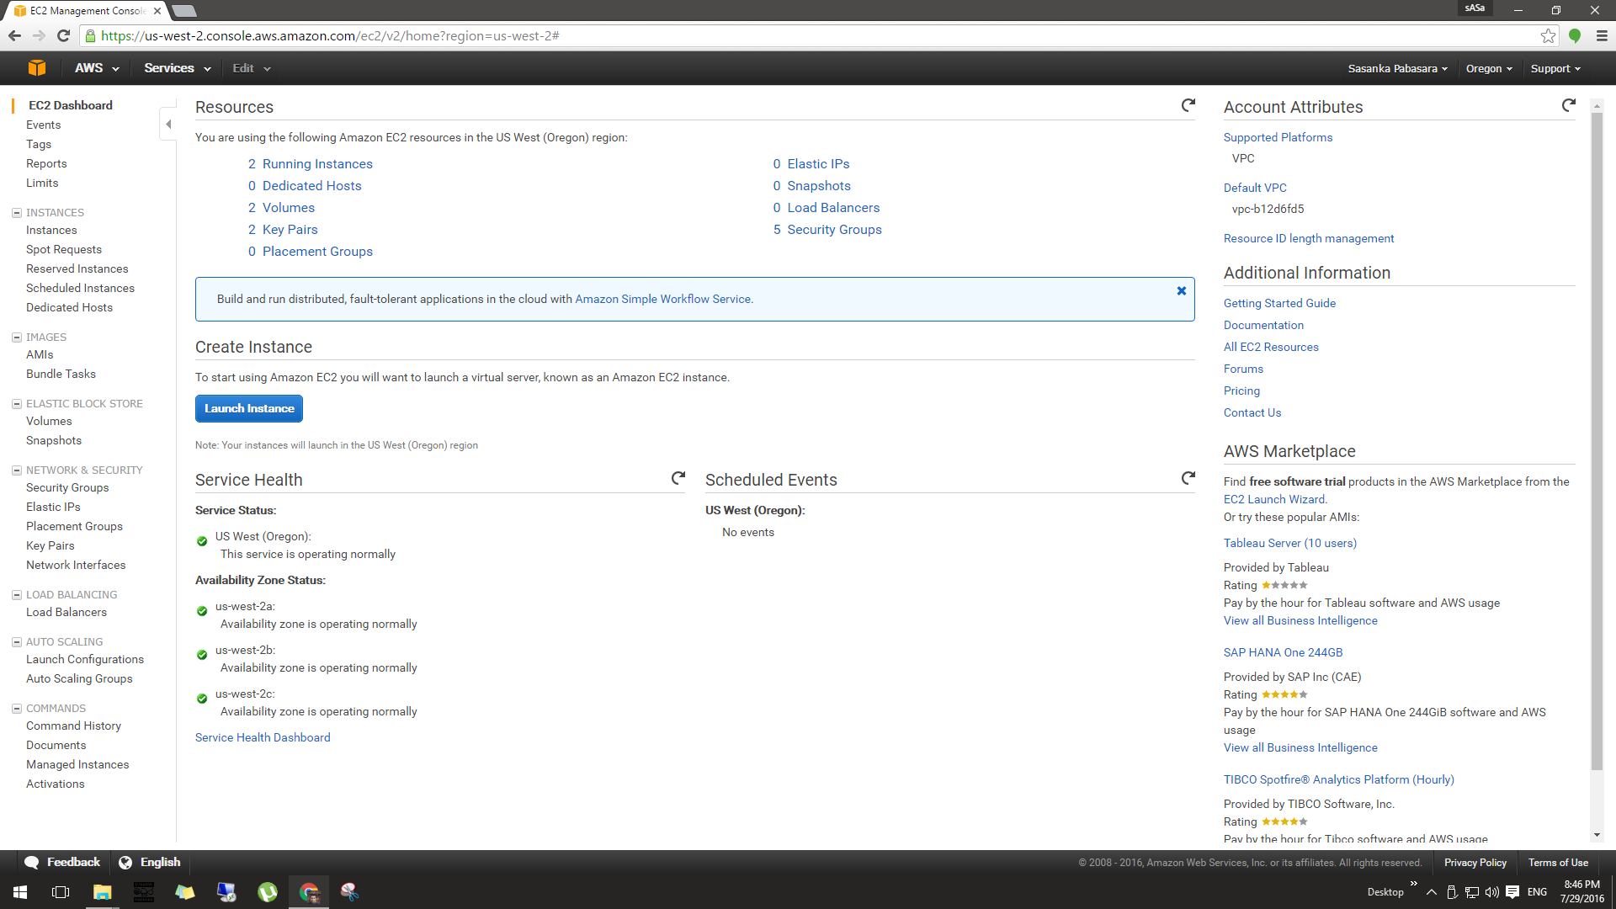
3. You will be redirected to a page that has a list of Amazon Machine Images (AMIs) then you need to select “Microsoft Windows Server 2012 R2 Base” which is a free AMI.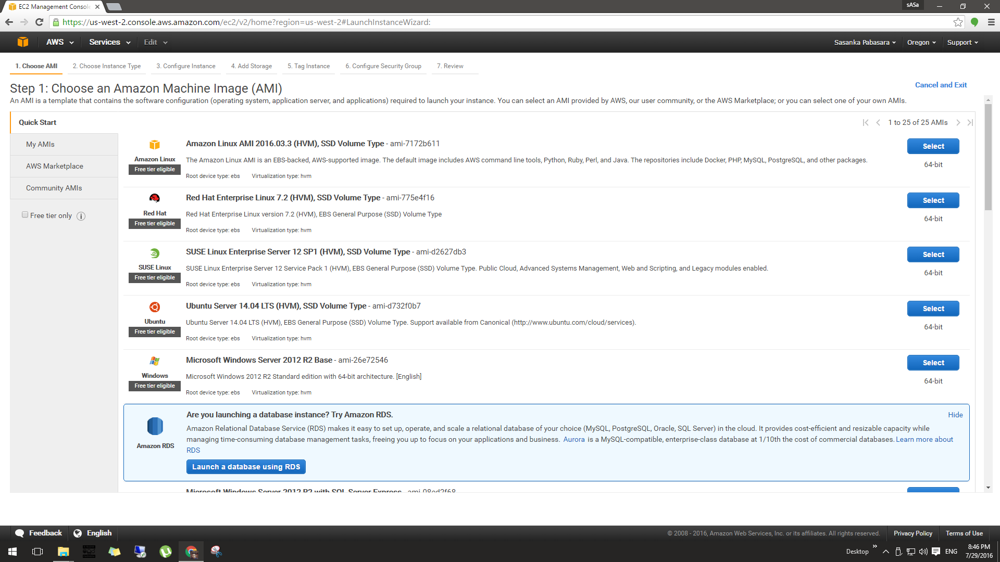
4. As the next step you will be asked to select the instance type. 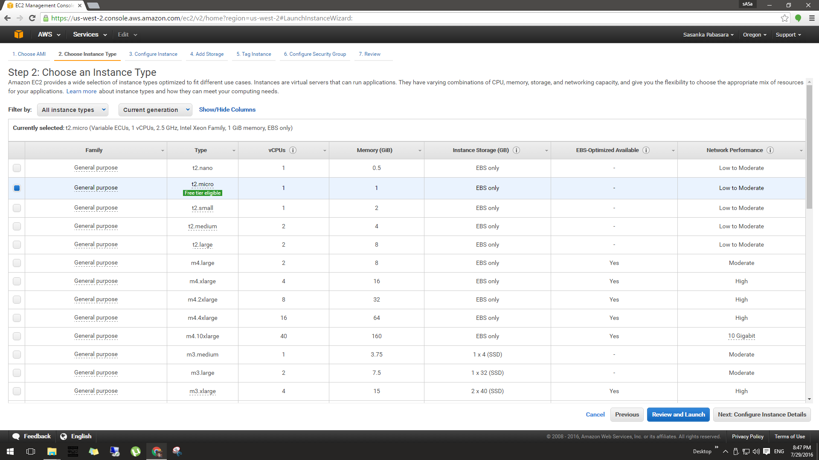
5. Then the instance launching happens after clicking “Launch” button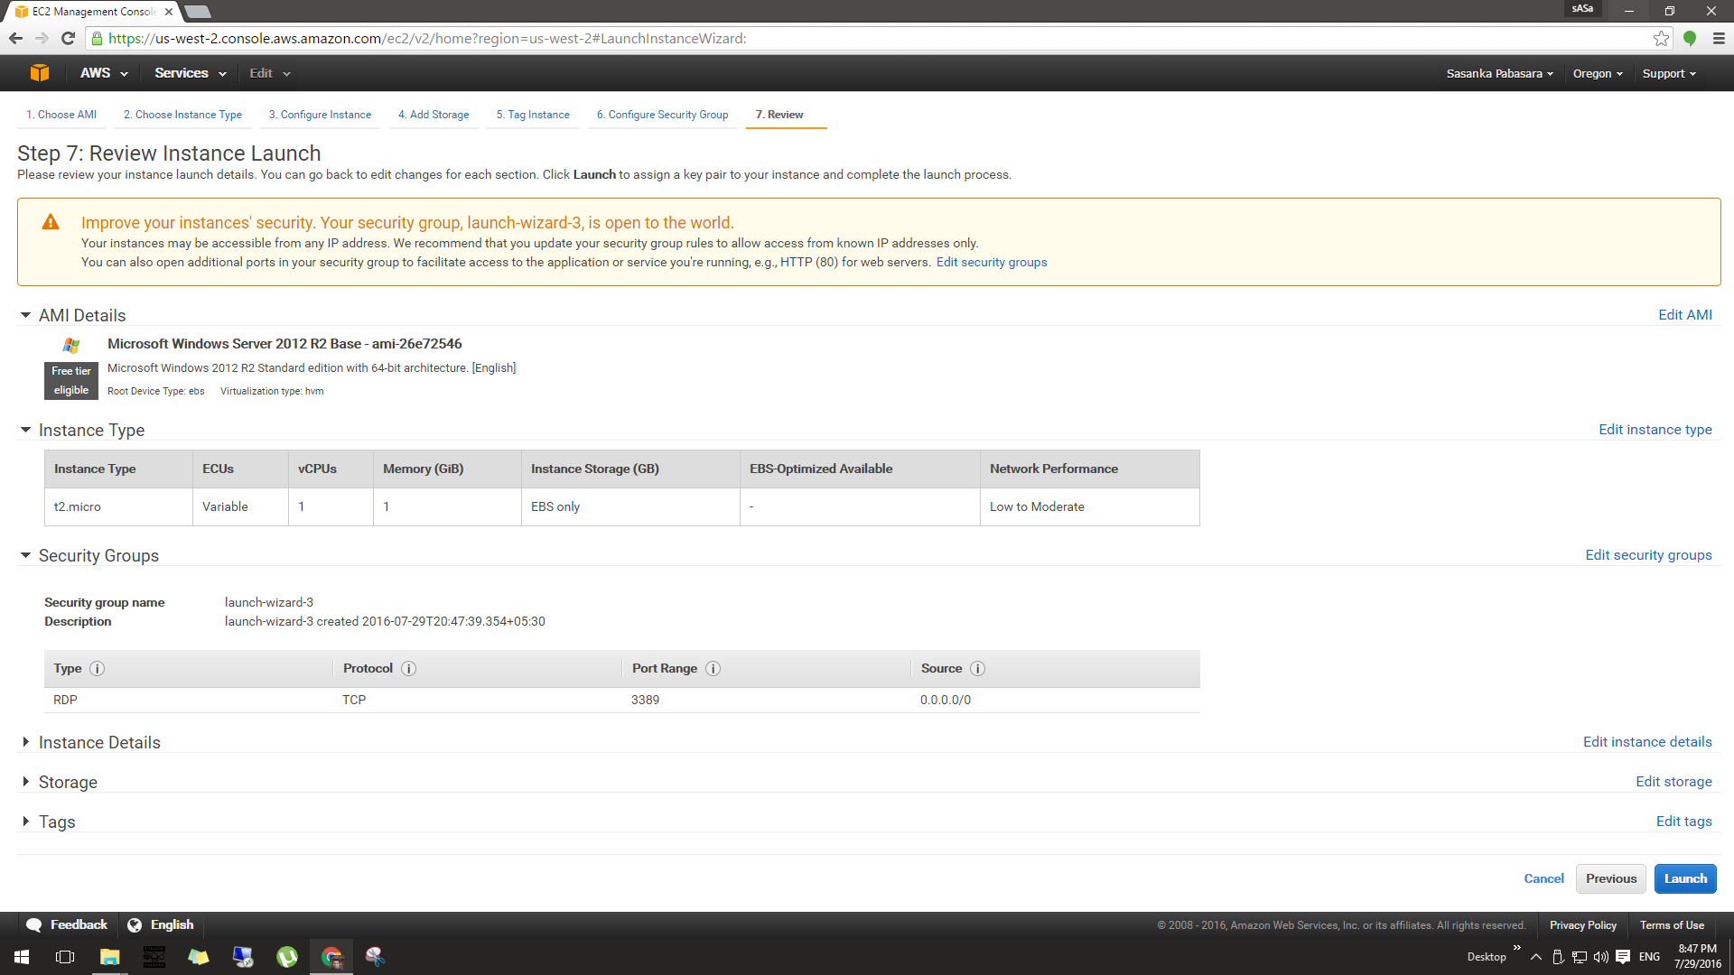
6. Then you need to create and download a key pair, key pair includes a private key and it allows you to connect with your instance..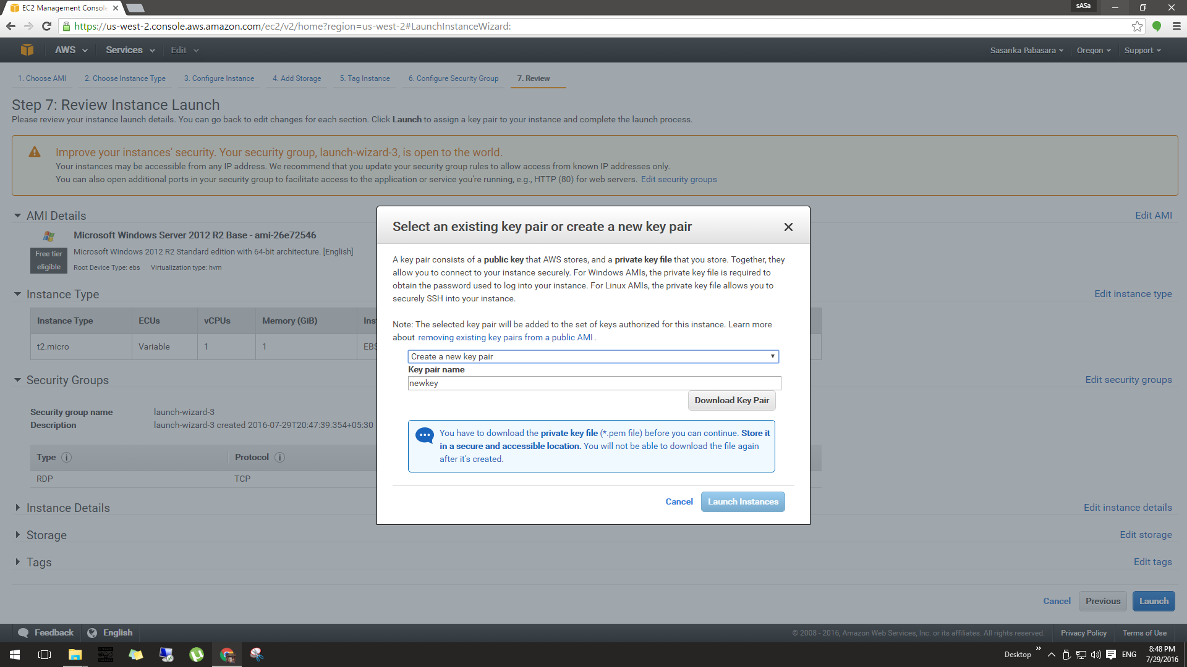

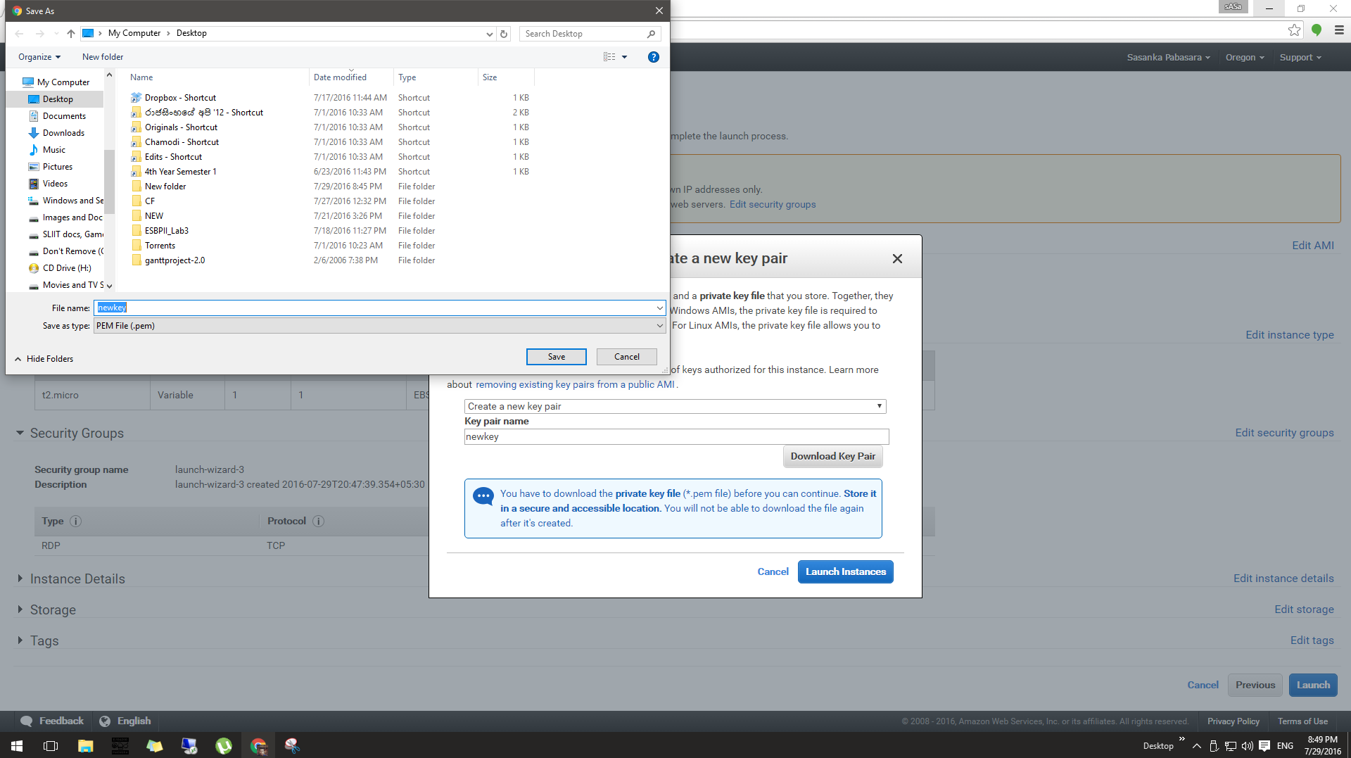 After downloading your key pair you can launch your instance.

1. The status which has “pending”, is the newly created instance, this may take a minite or two to convert the status pending to running.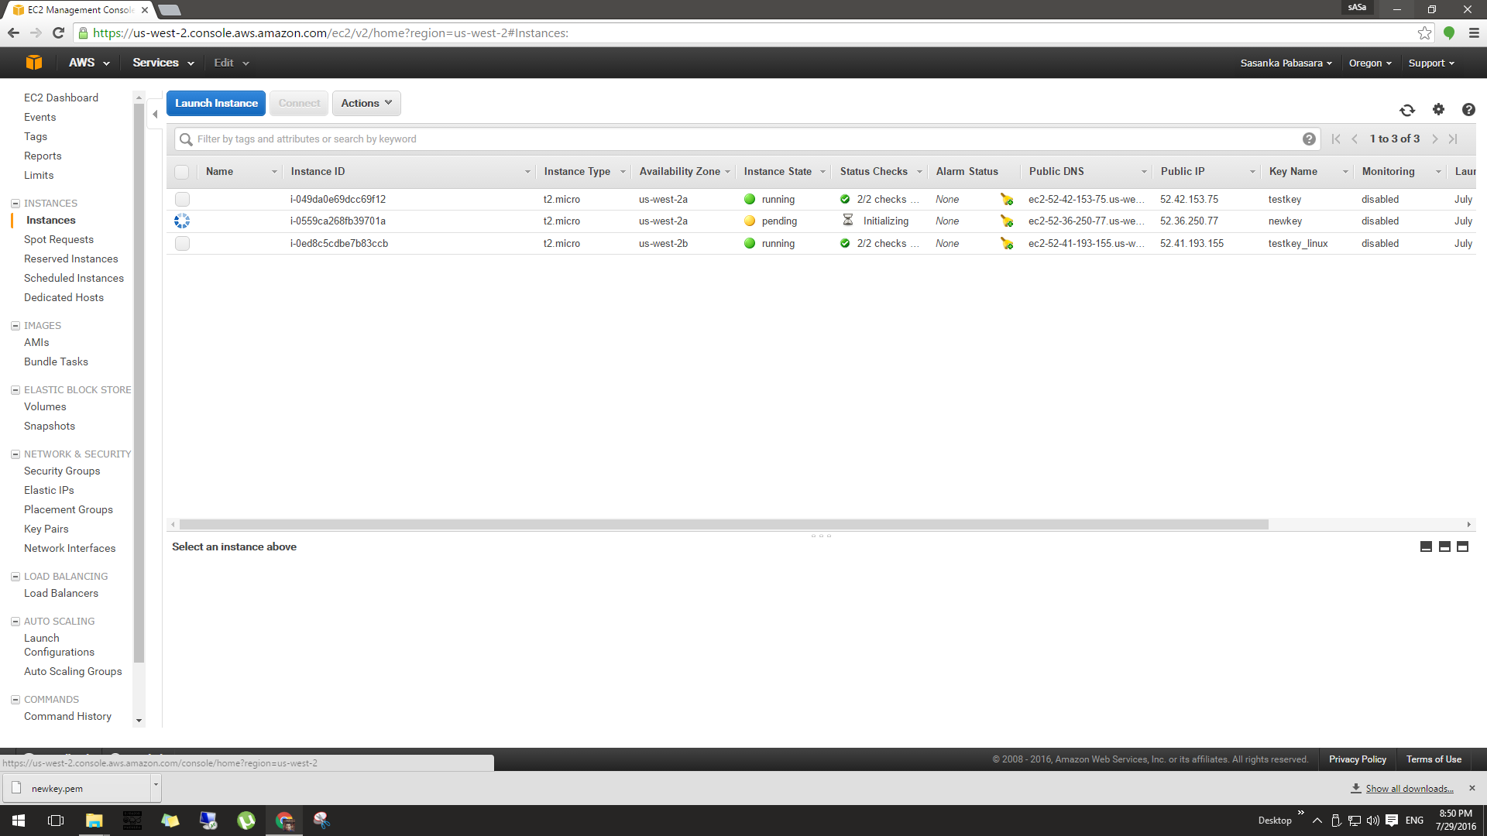
2. When your instance is in running state you can right click on it and connet to your instance by providing your private key, the AWS system will decrypt your downloaded private key and will check with their public key for a match.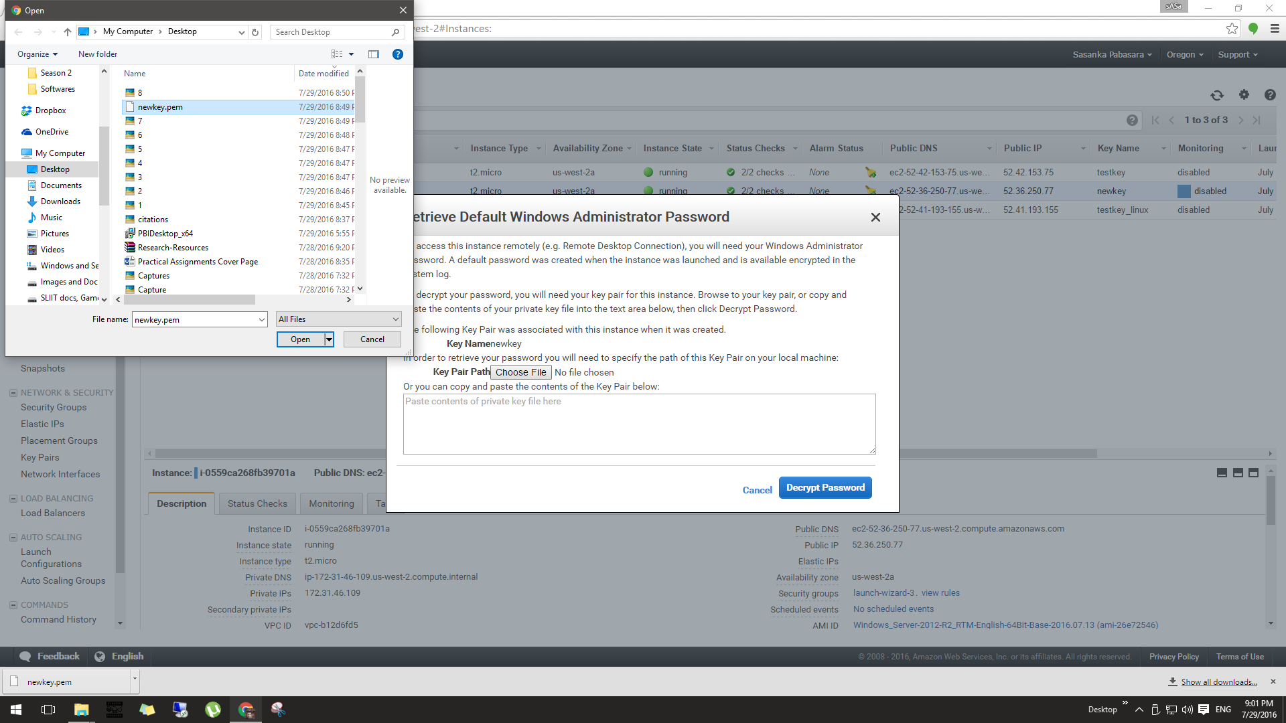
3. After confirming your key pair successfully you can open up your Remote Desktop Connection application from your host computer and then use your IP address of the instance as the computer and the password which is decrypted in previous step as the password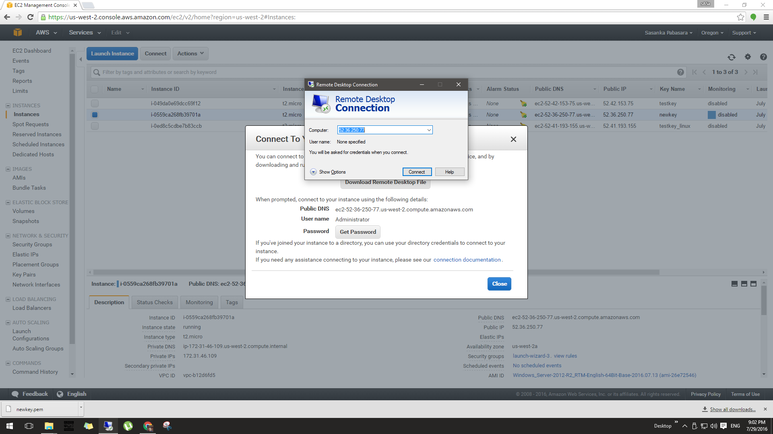
4. Now you are in a virtual windows instance and you can do any work you do with your host computer in this virtual instance as well.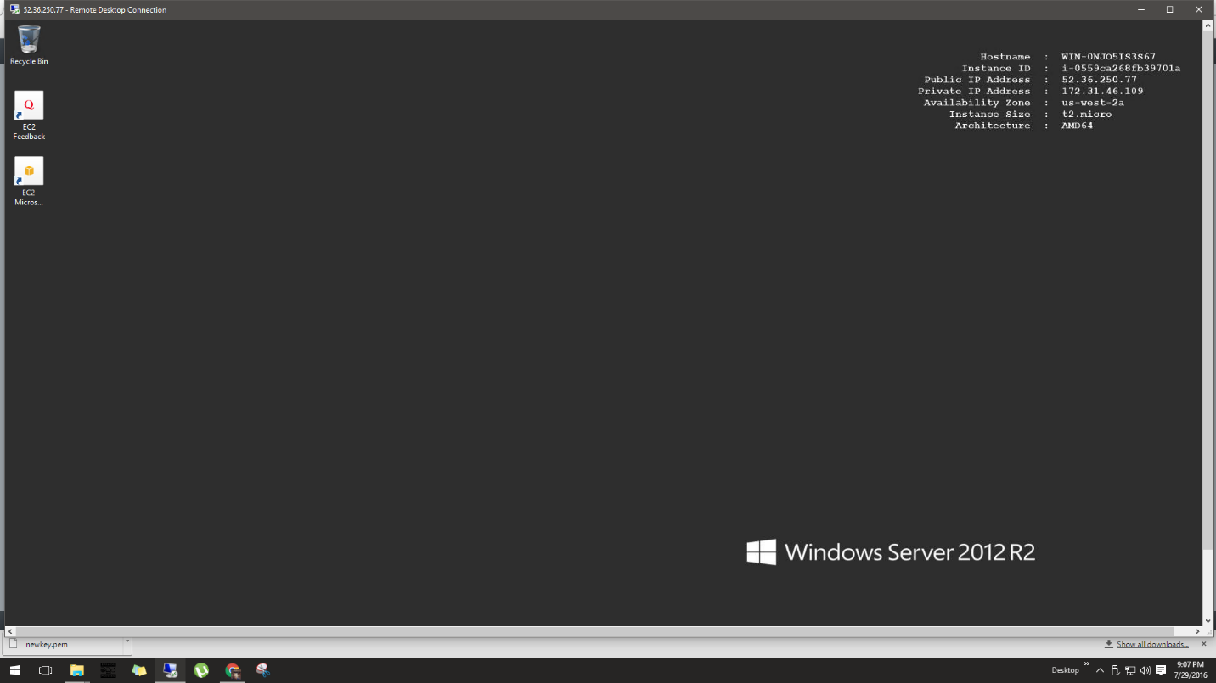

**Working with Windows Virtual Instance**

* Googling in your newly luanched windows instance ☺

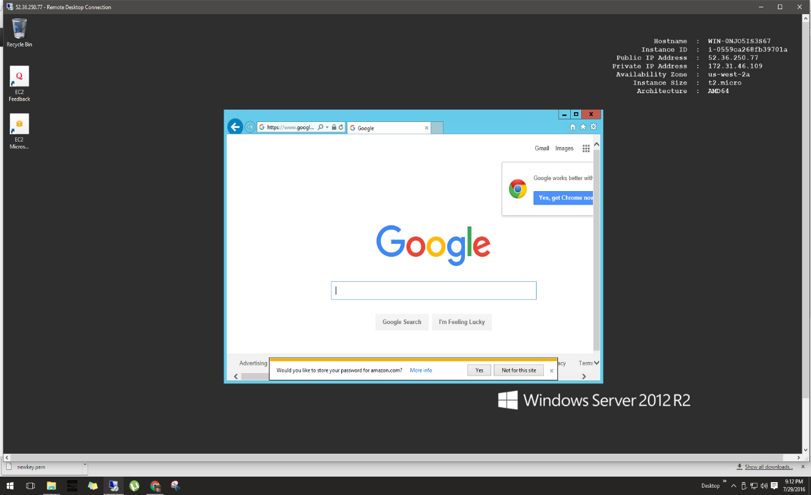

**How to create a Linux instance using AWS?**

1. Like in windows this time, select Amazon Linux AMI
2. Then you will get an Ubuntu instance in your instances tab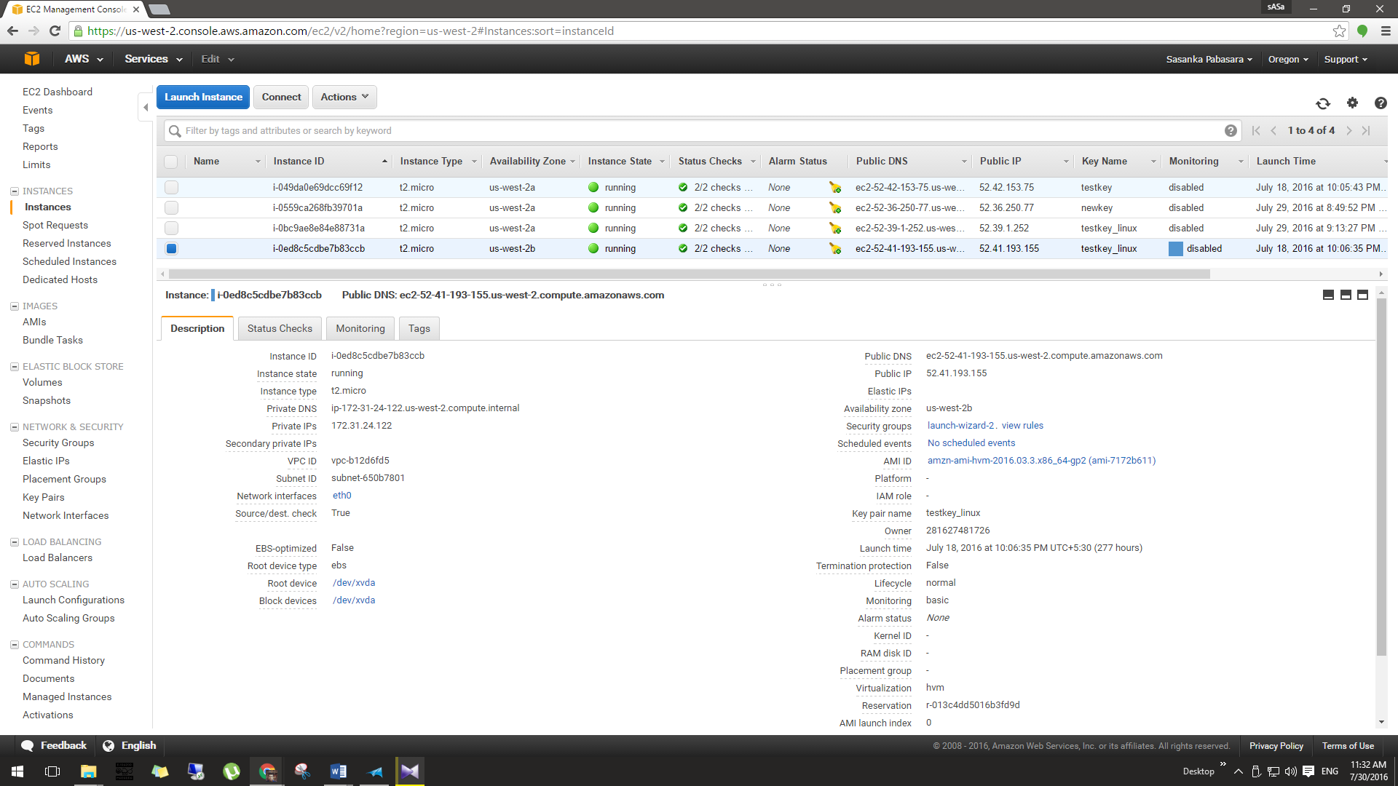
3. To connect into Ubuntu instances you just can’t right click and click connect just like we did in previous example.

(You will be needed two additional applications called putty and puttygen, where putty is going to help you to connect with your instance and puttygen will help you to download and decrypt your key pair.)

1. Putty is just like your Remote Desktop Connection application, you will need to provide IP address of your instance and the decrypted password.
   1. IP address : Since this is an Ubuntu instance,

ubuntu@<Public DNS of your instance>

[ubuntu@ec2-52-41-193-155.us-west-2.compute.amazonaws.com](mailto:ubuntu@ec2-52-41-193-155.us-west-2.compute.amazonaws.com)

* 1. Password :
     1. Putty does not natively support the private key format (.pem) generated by Amazon EC2. Therefore puttygen, which can convert keys to the required Putty format (.ppk). You must convert your private key into this format (.ppk) before attempting to connect to your instance using putty. Click load and find your .pem file then load it into your puttygen application then click “Save Private Key” which is going to be your key.

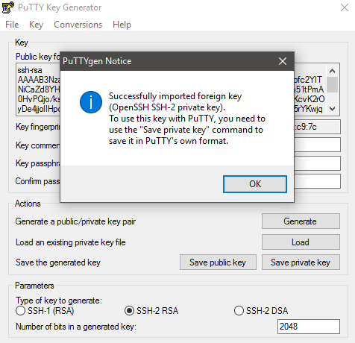

* + 1. Your private key is now in the correct format for use with putty. You can now connect to your instance using putty’s SSH client. Provide your IP address as we discussed previously as the host name.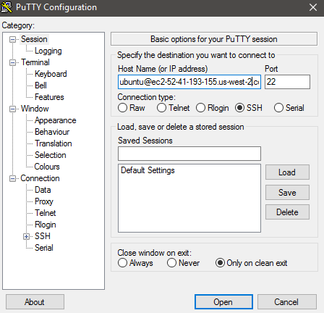
    2. Go to Connection->SSH->Auth tab then browse your newly generated .ppk file and load it as the private key.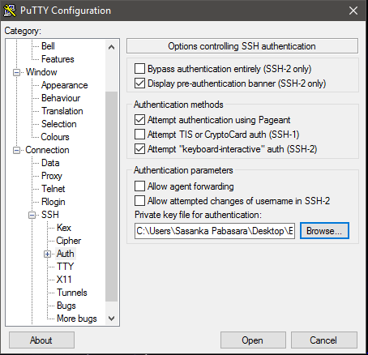
    3. Click Open, now you will get an Ubuntu console instance

**Working with Ubuntu Virtual Instance**

In here you can execute any Ubuntu command ☺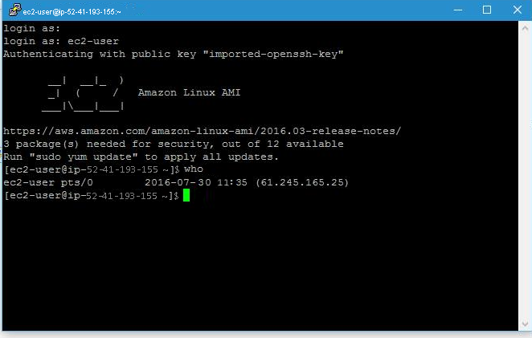

**How to create a DB Instance using AWS?**

1. Select “RDS” under “DATABASE” category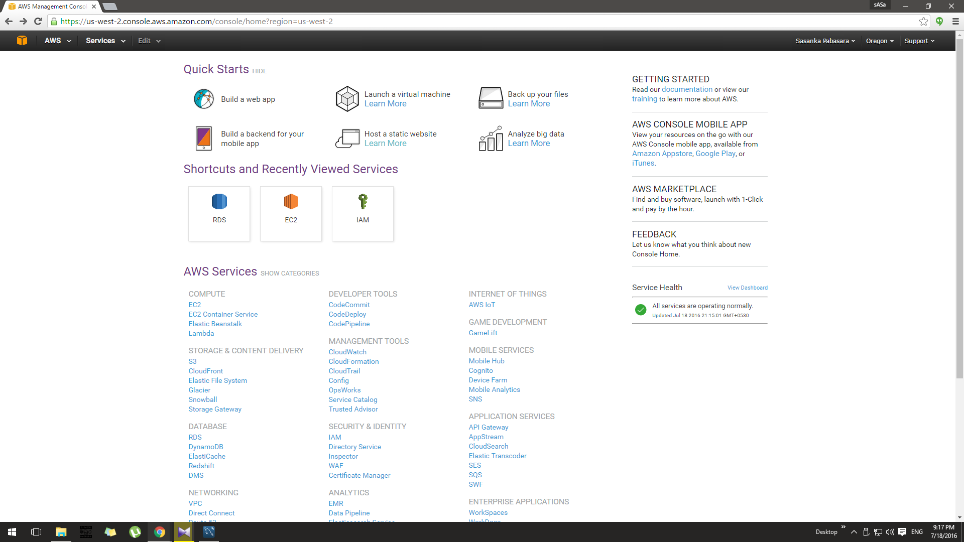
2. Then you will get an interface, in there you can start the process to launch your DB instance
3. Then you need to decide whether you are creating this instance for production purpose or for testing purpose.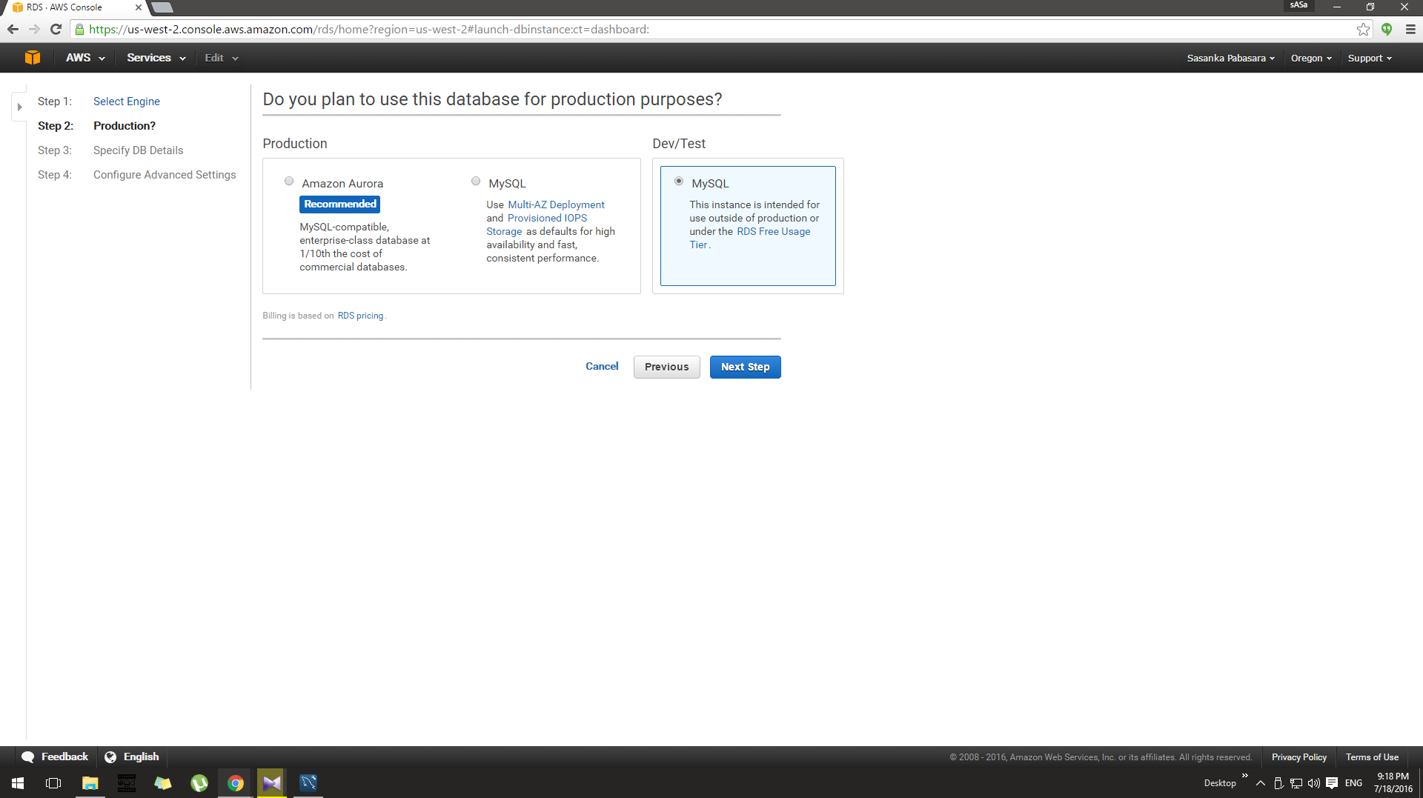
4. Then you need to fill the details as follows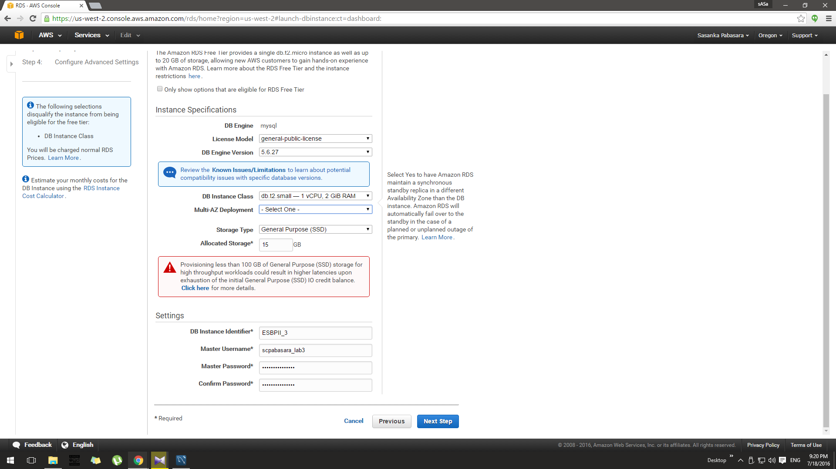

Note: You can decide the size of your storage for this db instance.

1. In the next step keep all the details as default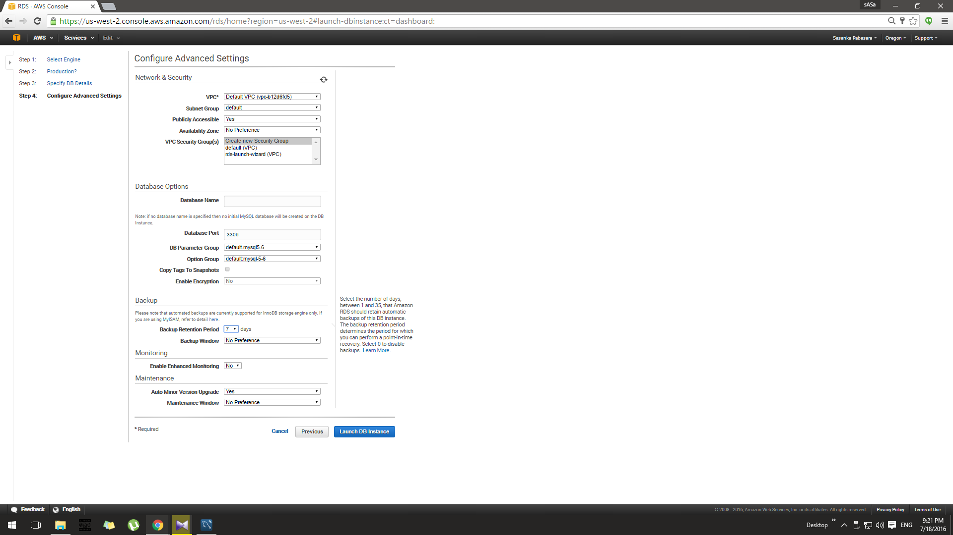
2. After completing these 5 steps you can finally launch your DB instance by pressing View Your DB Instance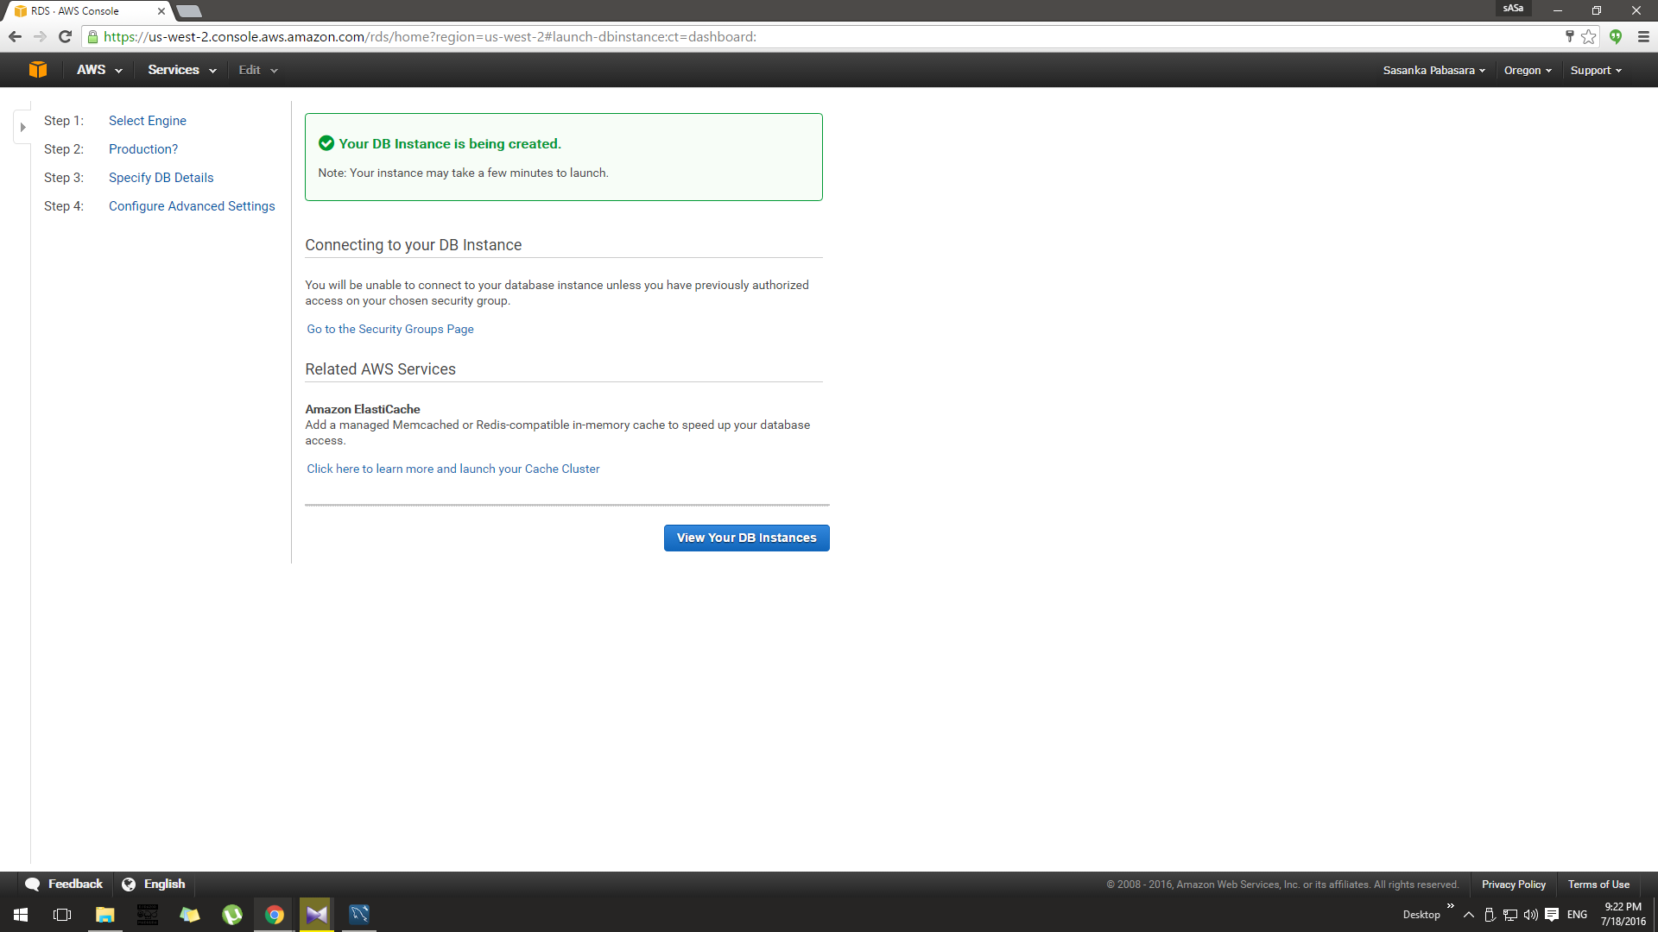

Then you will get a list of created db instances and which are available for use marked as available in the status column, there are several status like creating -> backing up -> available. Every DB instance which is available for use has an Endpoint which is going to be the Hostname for the MySQL Workbench connection.

1. Copy down your endpoint address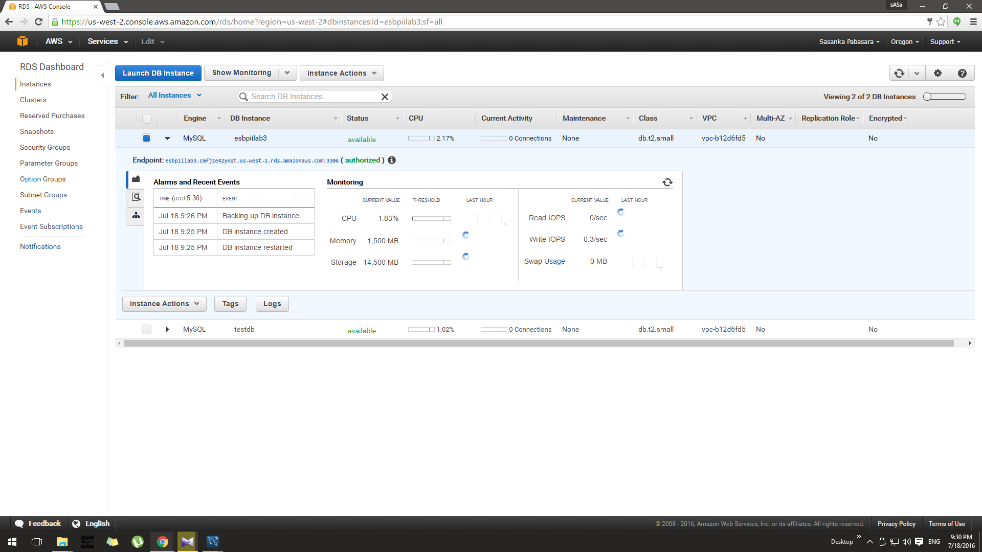
2. Then open up your MySQL Workbench, and fill the details as bellow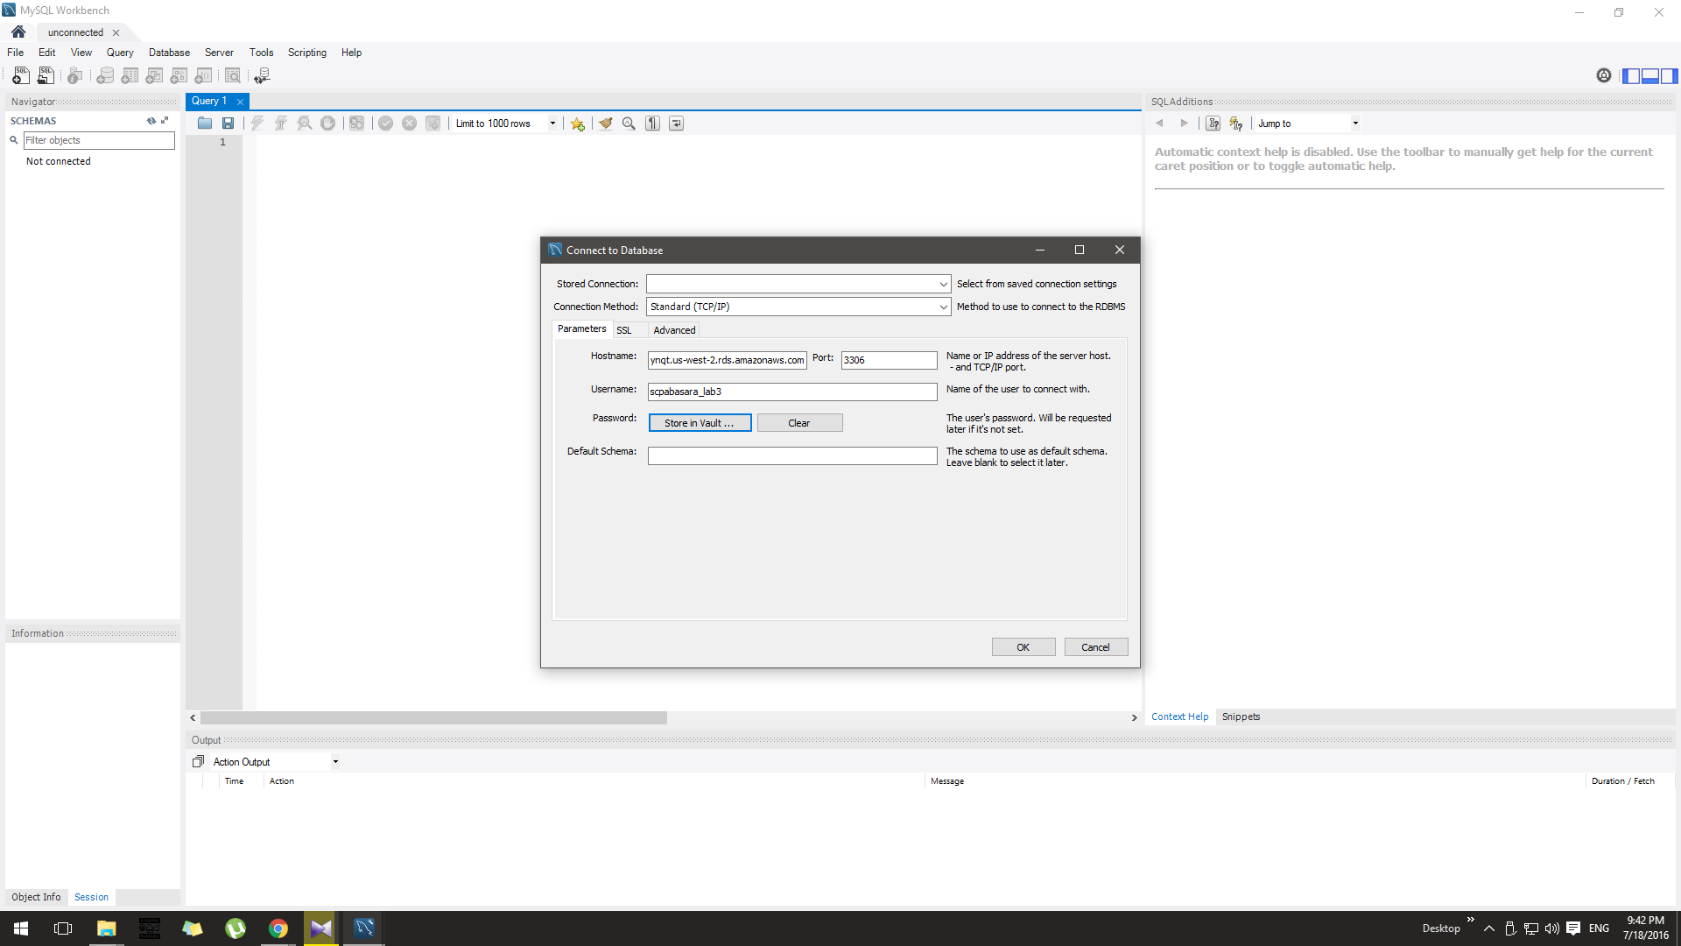
3. Then you need to connect to your newly created schema using the SCHEMA category in your Navigator bar.